William Eddy

Data Management – Fall 2018

**Normalization Quiz**

You will receive one point for each correct answer below as extra credit on the Activity portion of the Mid Term Exam. Each response below must be one in which you create and not one previously seen. (Max of 5 points)

1. Create a table of information that reflects a 1NF violation.

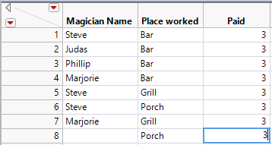

1. Create a Sentence structure of data that reflects a 2NF violation.

THINGS (ThingName, ThingLocation, AvgOriginalPriceWorldwide)

1. Create a table of information that reflects a 4NF violation.

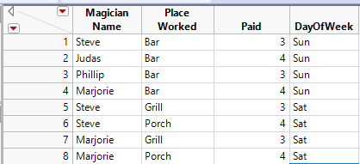

1. Create a sentence structure of data that reflects a 3NF violation.

THINGS (ThingName, ThingLocation, AvgOriginalPriceWorldwide, LocationDistanceFromFactory)

1. What is the main purpose of normalization?

Avoid data anomalies. Secondary purpose is to conserve storage space.